HOMEWORK
Power USage take home question
You will need:
- A copy of your utility bill, showing annual usage
- First Solar Series 6 Information Sheet

- How many FS-6445 solar panels are required to offset 100% of your electric bill assuming the power conversion from DC to AC is only 80% efficient, and you have 6hrs of sunlight (irradiance is 1000w/m²)?

- What is the area in sqft required for the number of FS-6445 solar panels required to offset your electric bill?

The answer sheet in excel, along with some additional information from the tour, will be available for download at https://schoolsup.org/connect

Step-by-Step Guide

- Find Your Annual Power Consumption from Your Utility Bill.
  - If your bill does not show an annual amount, take each month and add them together (the example below shows about 13,000 kWh used)
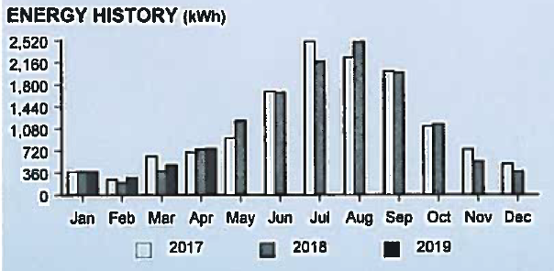

Input YOUR Annual Consumption from your bill:

- Find how much power you are using each day in your home.

Equation: Annual Consumption =
Daily Power Usage:
365 Days

- Find the number of kilowatts needed to offset 100% of energy used (kW)

Equation: Daily Power Usage =
# of kW to Offset Electric Bill:
6 hours of sunlight

Teacher’s Note: If the First Solar S6445 Module is in the sun for 6 hours straight at 1000 w/m², this is how much kW of power will be produced in a single day. Because on average there is only 6 hours of sunlight each day at 1000 w/ m² (this changes based on the time of year as well, but for this purpose, we are using 6 hours).

- Solar modules produce DC power and in order to put the power back on the grid so it can be used in your home, you must convert to AC power. This conversion results in an average loss of 20%. To make up for that loss we multiply the Offset amount by 1.2.
DC to AC Power Conversion Adjustment:
Equation: # of kW to Offset Electric Bill x 1.2 =

- We need to change the DC to AC power conversion from kW/h to watts (to do this we multiply the number from #4 x 1000) and divide by 445 watts (this is the watts for 1 single FS 6445 module). The result is the # of modules you would need to install to produce the amount of power you have used in the past year in your home.
# of First Solar Modules Needed (ROUND UP to Next Whole Number):
Equation: DC to AC Power Conversion Adjustment x 1000 kW/h =
445 (amount of power an FS module puts out per 1000 w/m²)

- Based on the # of modules we need, now we want to know how much area and square footage is required to offset our energy usage. To do this we take the number of FS Modules (round up) that we calculated above and multiply it by the size of the FS S6445 Module (26.6 sq ft).
Square Footage needed to install all FS modules required to offset 100% of your electric bill:
Equation: # of FS Modules needed x 26.6 sq feet

